Practical No:-15

X. Program code:
import java.net.*;

public class InteDemo {
public static void main(String[] args) {
try {
URL url = new URL("http://www.javatpoint.com/java-tutorial");

System.out.println("Protocol: " + url.getProtocol());
System.out.println("Host Name: " + url.getHost());
System.out.println("Port Number: " + url.getPort());
System.out.println("File Name: " + url.getFile());

} catch (Exception e) {
System.out.println(e);
}

}

@Override
public String toString() {
return "InteDemo []";
}
}

OUTPUT:-
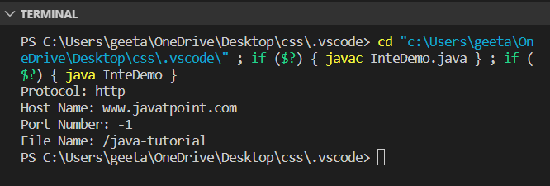

XIII . Exercise
Q1. Write a program using URL class to retrieve the host, protocol, port, and file of URL http://www.msbte.org.in
import java.net.*;

public class InteDemo {
public static void main(String[] args) {
try {
URL url = new URL("https://msbte.org.in/");

System.out.println("Protocol: " + url.getProtocol());
System.out.println("Host Name: " + url.getHost());
System.out.println("Port Number: " + url.getPort());
System.out.println("File: " + url.getFile());

} catch (Exception e) {
System.out.println(e);
}
}
}

Output:-
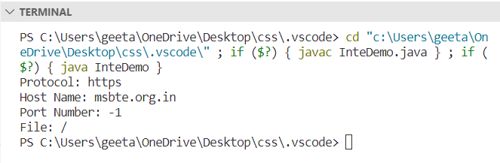

Q2. Write a program using URL and URLConnection class to retrieve the date. content type, content length information of any entered URL

import java.io.IOException;
import java.net.URL;

public class URLDemo {

public static void main(String [] args) {
try {
URL url = new URL("https://www.tutorialspoint.com/index.htm?language=en#j2se");

System.out.println("URL is " + url.toString());
System.out.println("protocol is " + url.getProtocol());
System.out.println("authority is " + url.getAuthority());
System.out.println("file name is " + url.getFile());
System.out.println("host is " + url.getHost());
System.out.println("path is " + url.getPath());
System.out.println("port is " + url.getPort());
System.out.println("default port is " + url.getDefaultPort());
System.out.println("query is " + url.getQuery());
System.out.println("ref is " + url.getRef());
System.out.println("Date " + url.toDate());
} catch (IOException e) {
e.printStackTrace();
}
}
}
Output:- 